NASA Technologies
Management Using Process Libraries and Electronic Handbooks
(Where Shakespeare Meets Freud)
Dr. Barry E. Jacobs
barry.e.jacobs@comcast.net

Abstract
We believe that to truly understand one's universe, one must see it thru multiple "eyes" and also have tools to "communicate" these views. To do this, we propose editable and cost-saving process documentation “plays” for process developers and participants to help them quickly and effectively learn, integrate, test, teach, and work together. These “plays” may be added to new or existing systems. Benefits are that it facilitates the collection of system and organizational requirements, does not anger/upset people whose opinions are heard, and it increases the interaction between managers, process developers, and participants. For each subprocess, an “Integration View” is the integration or combination of other subprocess views. An "Integration View" facilitates intra- and inter-organization communication. We illustrate using NASA Technologies Management. In Section 1, we examine common problems that arise in the management of complex distributed processes. In Section 2, we provide an overview of tools that are solutions to these problems. Simply speaking, we regard subprocesses as “plays” and let organizations put on productions of the “play”. In Section 3, we provide examples of these tools. In Section 4, we outline some complex distributed processes in the Federal Government that are applications of the methodology. In Section 5, we conclude with some final thoughts.

0. Introduction
In this paper, we deal with the important problem of managing complex distributed processes involving potentially thousands of participants. An example of such a process is the management of National Aeronautics and Space Administration (NASA) Technologies. NASA Technologies is a key ingredient of NASA Flight Projects which are the heart of NASA. Managing complex distributed processes is difficult due to 1) the complexity of the subprocesses, 2) the diversity of views of different organizations, 3) the diversity of views of teachers, documentors, managers, implementors, and participants taking part in the subprocesses, 4) subprocess Live-Cycle views, and 5) the “Game of Telephone” syndrome.

We believe that to truly understand one's universe, one must see it thru multiple "eyes" and also have tools to "communicate" these views. To do this, we propose editable and cost-saving process documentation “plays” for process developers and participants to help them quickly and effectively learn, integrate, test, teach, and work together. These “plays” may be added to new or existing systems. See Figure 0 (a). Benefits are that it facilitates the collection of system and organizational requirements, does not anger/upset people whose opinions are heard, and it increases the interaction between managers, process developers, and participants. For each subprocess, an “Integration View” is the integration or combination of other subprocess views. See Figure 0 (b). An "Integration View" facilitates intra- and inter-organization communication.
An outline of the paper is as follows:

In Section 1, we examine common problems that arise in the management of complex distributed processes. In Section 2, we provide an overview of tools that are solutions to these problems. Simply speaking, we regard subprocesses as “plays” and let organizations put on productions of the “play”. In Section 3, we provide examples of these tools. In Section 4, we outline some complex distributed processes in the Federal Government that are applications of the methodology. In Section 5, we conclude with some final thoughts.

Before going through the paper, the reader may want to first quickly look at some examples in Figures 3(a)-(p).

1. Problems
We discuss here some of the problems that are intrinsic to the management of complex distributed processes.

First, complex distributed processes tend to have lots of related subprocesses. For example, Figure 1(a) shows some of the subprocesses of NASA Technologies. Notice that we organize the subprocesses into five categories: Product Realization, Product Distribution, Support, Improvement, and Common.

Second, for each subprocess, we tend to have multiple organizations, each having their own view of the subprocesses. Some of these views may be proprietary. For example, Figure 1(b) shows some of the organizations participating in the NASA Technologies. In addition, there are also organizations that distribute the products that come out of the subprocesses as well as organizations that support and improve the subprocesses.

Third, within each subprocess organization, we have eight “Play Development” stages. See Figure 1(c). These are 1) summarizing (descriptions), 2) playwriting (outlines), 3) staging (mockups), 4) dress rehearsal (implementations), 5) performance (implementations), 6) evaluations (implementations), 7) revisions (outlines, mockups, implementations), and 8) closing.

Fourth, within each subprocess organization, we have numerous teachers, documentors, managers, implementors, and participants, each person having their own view of the subprocess. See Figure 1(d). It is very important that teachers, documentors, managers, implementors, and participants quickly learn and then establish integrated views for their roles in the subprocess.

Fifth, there are a number of subprocess Life-Cycle views that have to be dealt with in the management of subprocesses. See Figure 1(e). These factors reflect the Life-Cycle of organizations that participate in the subprocesses.

Sixth, as each person tries to pass-on their view of the subprocess, they omit details to the person(s) they are teaching. See Figure 1(f). This is called the The "Game of Telephone" Syndrome: Where People Pass-On Only Parts of the "Message".

Solutions to these problems are discussed in the next section. See Figure 1(g) for an overview of how editable and cost-saving process documentation tools can solve problems.

2. Solutions
We discuss here an overview of tools that are solutions to these problems.

Process Libraries (PLs) maintain organization's views of the subprocesses. See Figure 2(a). Here we have a section of the Process Library for a particular subprocess. Notice that there is a place for different organization's views of the subprocess. These will be described below.

Our basic approach is to wrap organization's subprocesses in a common envelope containing communication vehicles that facilitate intra- and inter-organization communication. See Figure 2(b). Notice that the envelope contains a number of items. Descriptions facilitate quick learning of the subprocess. Plays document the temporal flow of the subprocess and also have Implementation Mockups and Implementation versions. Documents define the documents used in the subprocess and also have Templates, Examples, Instructions, Implementation Mockups, and Implementation versions. Guidelines or Electronic Handbooks give user roles on how to participate in the subprocess and also have Implementation Mockups and Implementation versions. Worksheets facilitate the manager's monitoring of the subprocess and also have Implementation Mockups and Implementation versions. Contacts contain the names of the people who are able to answer questions about the subprocess. References provide alternative views of the subprocess. Credits provide the names of people who are part of the development of the organization's subprocess.

Some tools may be focused on during stages. See Figure 2(c).

Documents in Process Libraries have three levels of access. See Figure 2(d). Some documents are unconditionally accessible to all over the Internet via a hyperlink. Some documents need to be accessed only through an organization's library. Finally, some documents are proprietary and one needs individual permission to obtain them.

For each subprocess, an “Integration View” is the integration or combination of other subprocess views. An "Integration View" facilitates intra- and inter-organization communication.. See Figure 2(e).

Process Libraries are where Shakespeare meets Freud. See Figure 2(f). In Process Libraries, subprocesses are represented as "plays" where "actors" communicate thru the Internet. Each organization puts on its own "productions". For each role, Electronic Handbooks (EHBs) (also called Guidelines) guide "actors" thru their parts. Managers are "directors" using Worksheets as learning/management tools. Documentors serve as "playwrights". [Shakespearean] Organizations are represented as "families" having "multiple personalities". Subprocess "plays" and its "components" provide communication vehicles between members of the same family, different families, and families from different subprocesses. Documentors also serve as "family therapists". [Freudian]. The approach uses a modernization of the Socratic Method or Dialogue to gain consensus between teachers, documentors, managers, implementors, and participants. See Figure 2(g).

Process Libraries and Electronic Handbooks (EHBs) methodologies have been used in a number of operational applications. See Figure 2(h). Here we see a number of different projects throughout the US Federal Government.

The subprocess Life-Cycle views in Figure 1(d) are supported. See Figure 2(i).

Basic people principles are supported. See Figure 2(j). The failure of a management system to follow these basic principles will generally result in people not utilizing the system.

Subprocess/Play Developments are supported. Subprocesses are built and revised using the play development paradigm over multiple productions. See Figure 2(k). This enables one to develop the subprocesses in stages and at each stage learn and modify the subprocesses.
Process Libraries operations are supported. See Figure 2(l). This outlines the ongoing operational maintenance and responsibilities for running the Process Library. Specifically, here we deal with the steps of organization formulation, implementation, customer support, evaluation, update and closeout.
3. Some Examples

We provide some examples of tools outlined above.

Process Libraries are organized by subprocesses. See Figure 3(a). Here we show one level of the Process Library which list the subprocesses. For each subprocess, the library shows how organizations view their subprocess. See Figure 3(b). Here we have a section of the Process Library for a particular subprocess. Notice that there is a place for different organization's views of the subprocess.

For each organization, an organization's view for a subprocess is comprised of several components. See Figure 3(c). Descriptions summarize subprocesses. See Figure 3(d). Plays describe subprocess execution or temporal flow. See Figure 3(e). Documents describe subprocess data. See Figure 3(f). Guidelines/Electronic Handbooks describe user subprocesses. See Figure 3(g). Subprocess Worksheets facilitate subprocess manager communication with process developers and participants. See Figure 3(h). References list other related resources. See Figure 3(i). Credits acknowledge people's contributions. See Figure 3(j). Some tools may be focused on during stages. See Figure 3(k).

In addition, several other tools are relevant. Integration Tools allow item types to be seen across different organizations. See Figure 3(l). Electronic Handbooks (EHBs) help participants learn and execute their roles. See Figure 3(m). Demonstration Tools introduce the concepts to a community in their terms. See Figure 3(n). Requirements Capture Tools (RCTs) facilitate subprocess development. See Figure 3(o). Improvement Tools facilitate subprocess improvement. See Figure 3(p).

4. Other Applications
We discuss here several applications where the above methodology has been applied. See Figure 2(h).
NASA Small Business Innovation Research (SBIR) Programs (http://sbir.nasa.gov ). This program funds hundreds of small businesses all around the United States to develop and later market technology-based products. The NASA SBIR program constitutes roughly 50% of all of NASA's new annual contracts.

Department of Justice (DOJ) Bulletproof Vests Program (http://www.ojp.usdoj.gov/bvpbasi/). This program co-funds purchases of Bulletproof Vests for all eligible law enforcement agencies and jurisdictions across the United States and its territories. The Bulletproof Vests system was the 1999 Gold Award Winner of the Federation of Government Information Processing Councils (FGIPC) Intergovernmental Open Systems Solutions (IOSS) Awards program.

Department of Justice (DOJ) Block Grants Program (http://www.ojp.usdoj.gov/bvpbasi/). This program funds all eligible law enforcement agencies and jurisdictions across the United States and its territories and is one of the largest programs in the Department of Justice's Bureau of Justice Assistance.
Department of Health and Human Services (HHS) Health Resources Services Administration (HRSA) Grants (http://www.hrsa.gov/). This process represents hundreds of Health Resources Services Administration's grant programs. These programs fund doctors, nurses, hospitals all across the United States and its territories.
Federal Emergency Management Administration (FEMA) Grants (http://www.fema.gov/). This process represents hundreds of Federal Emergency Management Administration's grant programs. These programs fund disaster assistance all across the United States and its territories.
5. Summary
In this paper, we dealt with the important problem of managing complex distributed processes involving potentially thousands of participants. In Section 1, we examined common problems that arise in the management of complex distributed processes. In Section 2, we provided an overview of tools that are solutions to these problems. In Section 3, we provided some examples of these tools. In Section 4, we outlined some complex distributed processes in the Federal Government that are applications of the methodology.

We conclude with some final remarks. As is seen throughout this discussion, we believe that to truly understand one's universe, one must see it thru multiple "eyes" and also have tools to "communicate" these views. See Figure 4(a). As William Shakespeare said “All the world's a stage ...”. See Figure 4(b). Finally, Dr. Martin Luther King Jr. described some effects of separation. See Figure 4(c).

For more information about Process Libraries and Electronic Handbooks, see http://ehbs.us. For more papers on other applications, see http://ehbs.us/papers.

References
FGIPC. Bulletproof Vests System Wins FGIPC’s 1999 GOLD IOSS AWARD" Federation of Government Information Processing Councils (FGIPC), June 22, 1999.
Friel, Brian. Contract Cybernauts. Government Executive Magazine, August 17, 1997.
Gugliotta, Guy, NASA Sets Sights on a 'Paperless' Planet. Washington Post (A11), August 19, 1997. (Federal Page)
Hendrix , Susan M.. Department of Justice Invests In Goddard Technology. Goddard News, Goddard Space Flight Center, National Aeronautics and Space Administration, December 17, 1999.
Harreld, Heather. NASA's Electronic Handbooks Offer Paper-Free Management. Federal Computer Week, August 18, 1997.
Johnson, Doug. Justice Department to Use Internet to Help Protect Officers. United States Department of Justice Press Release, April 19, 1999. (Photograph)
Makulowich, John. NASA E-Commerce Solution Gains Attention. Washington Technology, October 8, 1998.
NASA. NASA Tames a Paper Beast. NASA Tech Briefs. January 1998
Steigerwald, William.Time and Cost Savings Result From Internet Software Tool Developed For Electronic Process Management. National Aeronautics and Space Administration/ Goddard Space Flight Center Press Release. August 1, 1997.
USFA Press Release "Over 19,500 Applications Received For Firefighters Grant Program", April 15, 2002.

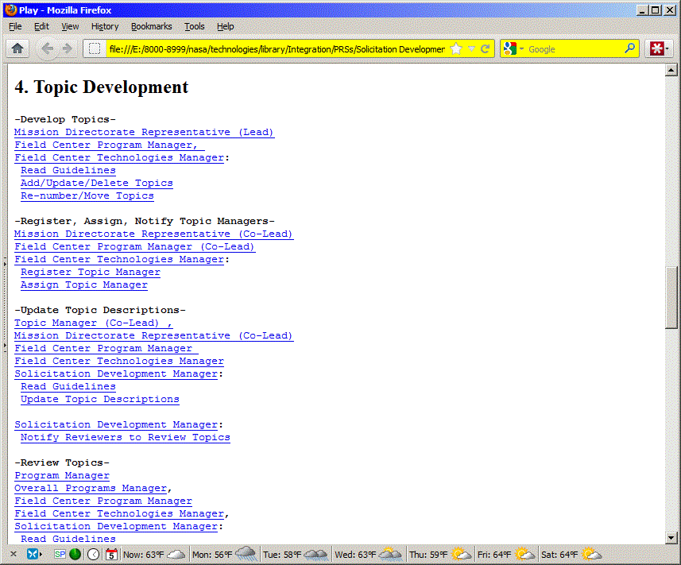

Figure 0 (a). Plays describe subprocess execution.

Figure 0 (b). For each subprocess, an “Integration View” is the integration or combination of other subprocess views.
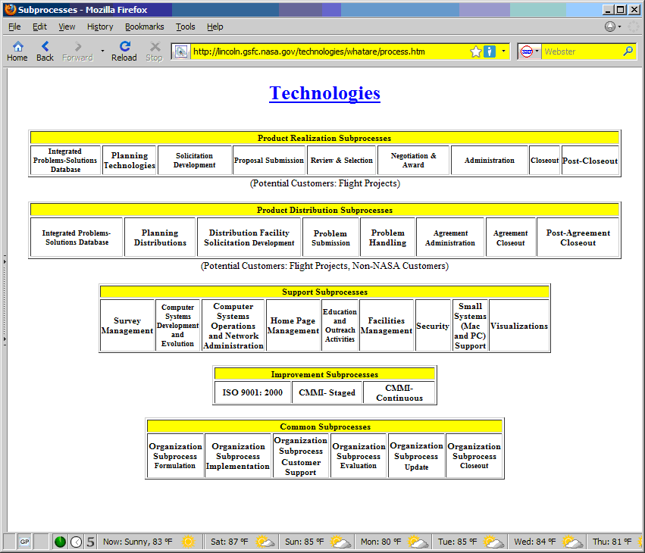
Figure 1(a). Subprocesses.
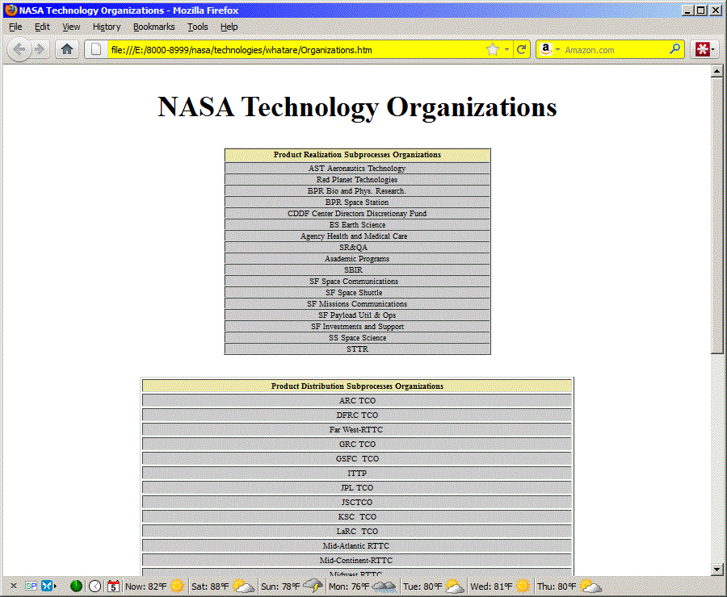
Figure 1(b). Subprocess organizations.

Figure 1(c). The eight “Play Development” stages.

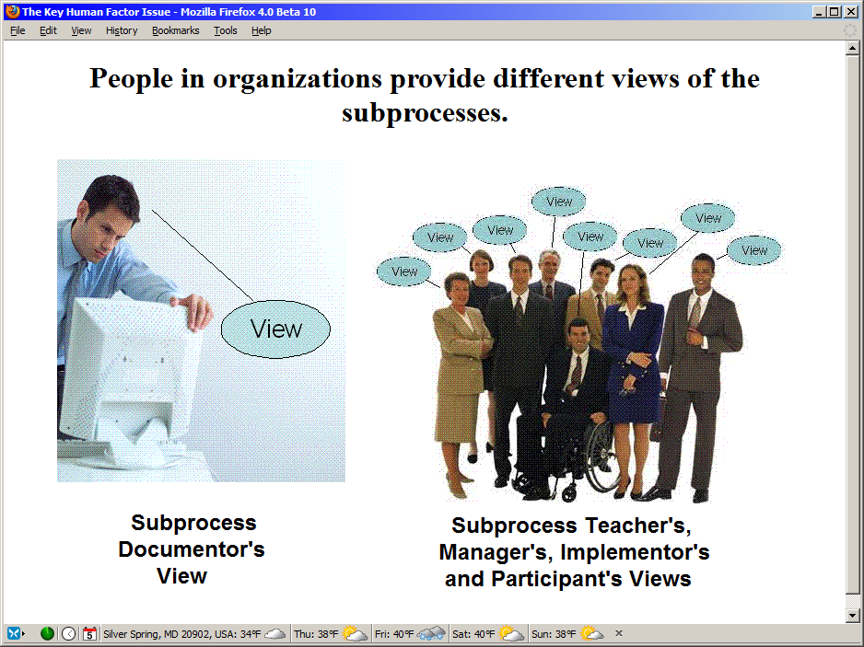
Figure 1(d). People in organizations provide different views of the subprocesses.
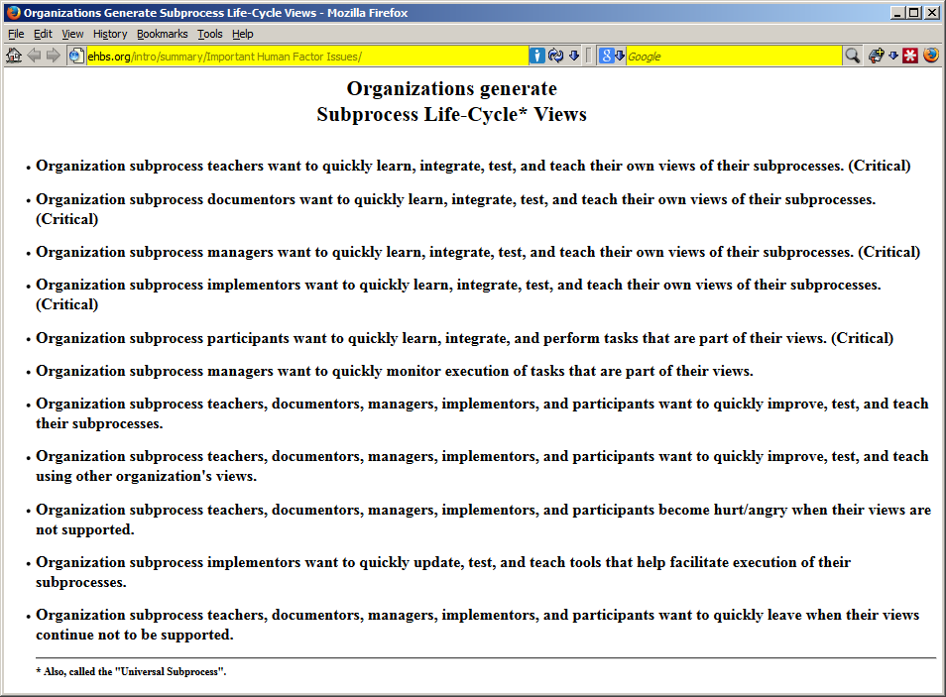
Figure 1(e). Subprocess Life-Cycle Views.
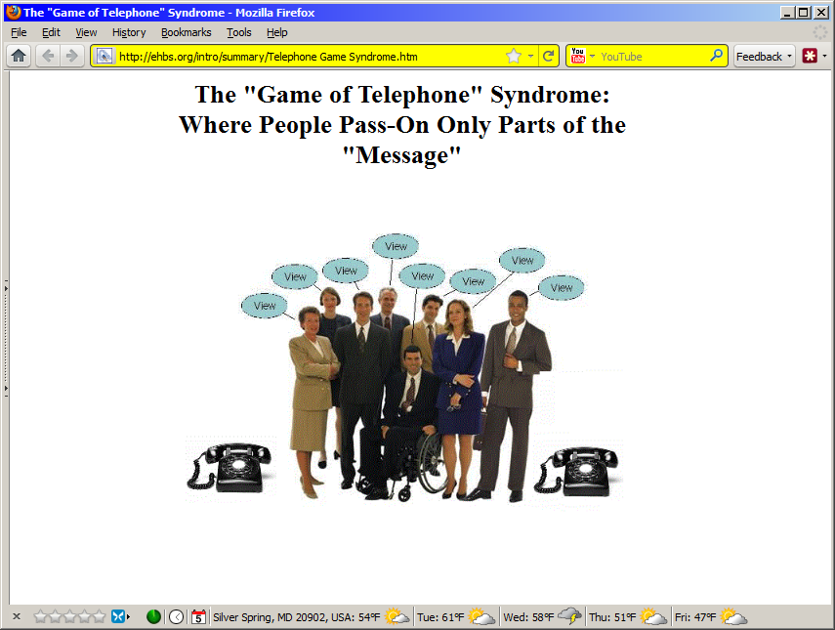
Figure 1(f). The "Game of Telephone" Syndrome:
Where People Pass-On Only Parts of the "Message".
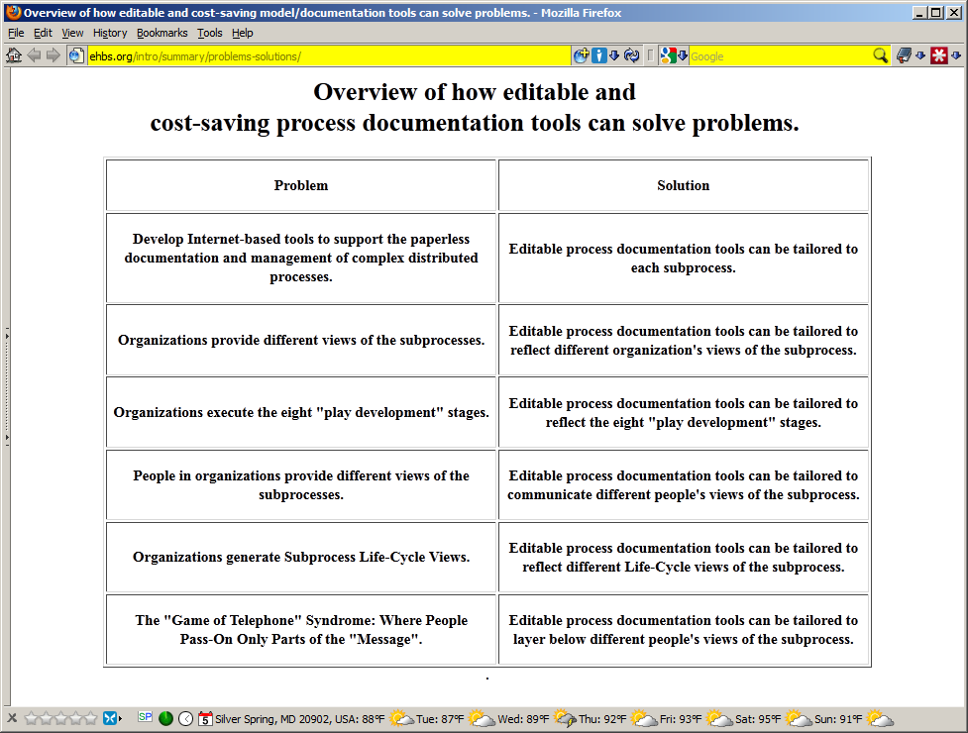
Figure 1(g). Overview of How Editable and Cost-Saving Process Documentation Tools Can Solve Problems.
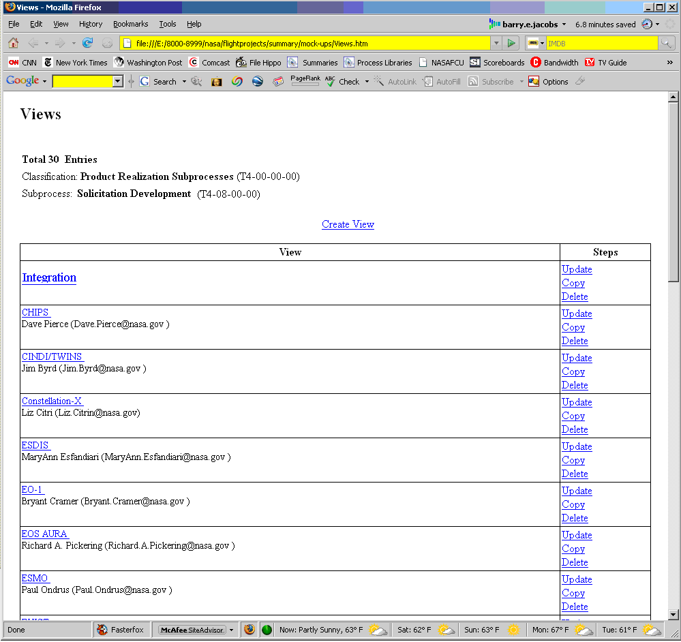
Figure 2(a). Process Library.
Figure 2(b). Subprocesses in a common envelope.
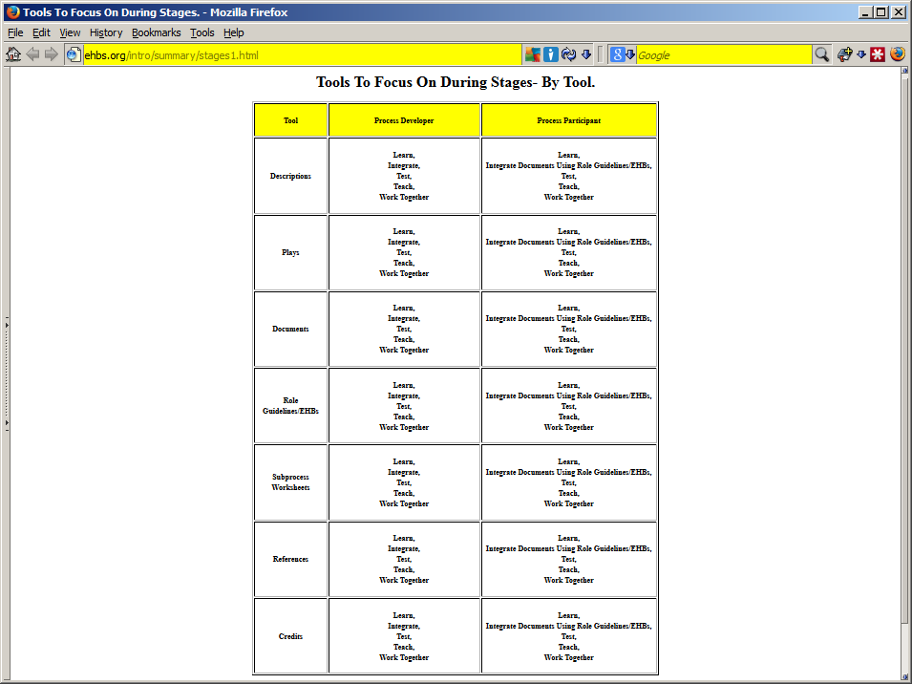
Figure 2(c)(1). Some tools may be focused on during stages- by tool.
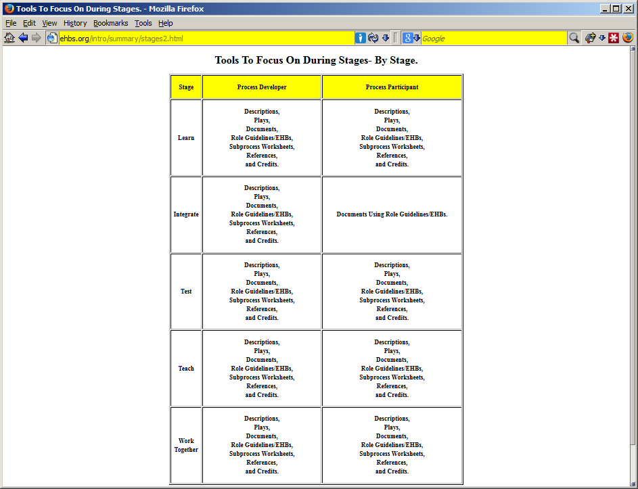
Figure 2(c)(2). Some tools may be focused on during stages- by stage.
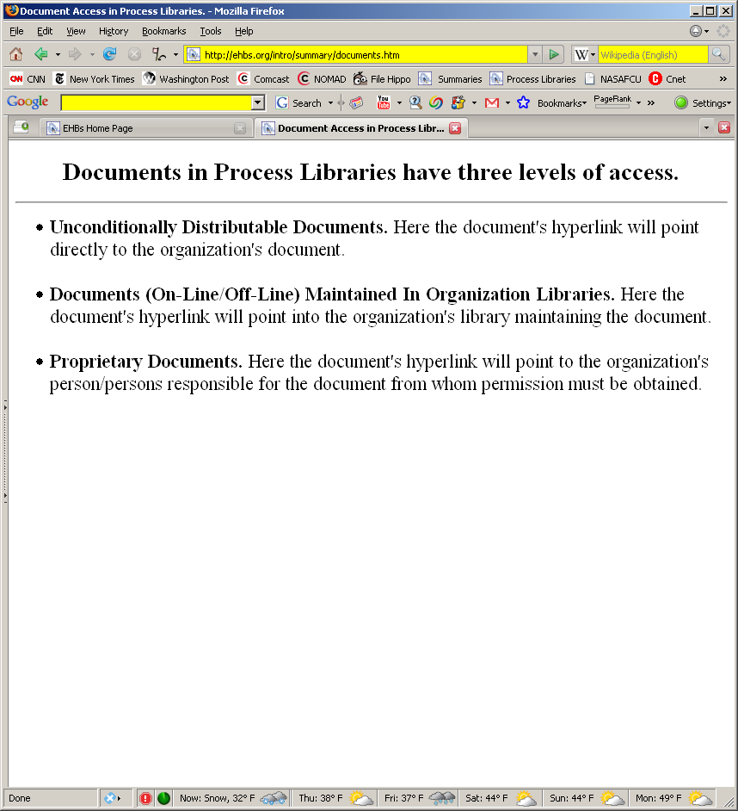
Figure 2(d). Documents in Process Libraries have three levels of access.
Figure 2(e). For each subprocess, an “Integration View” is the integration or combination of other subprocess views. An "Integration View" facilitates intra- and inter-organization communication.
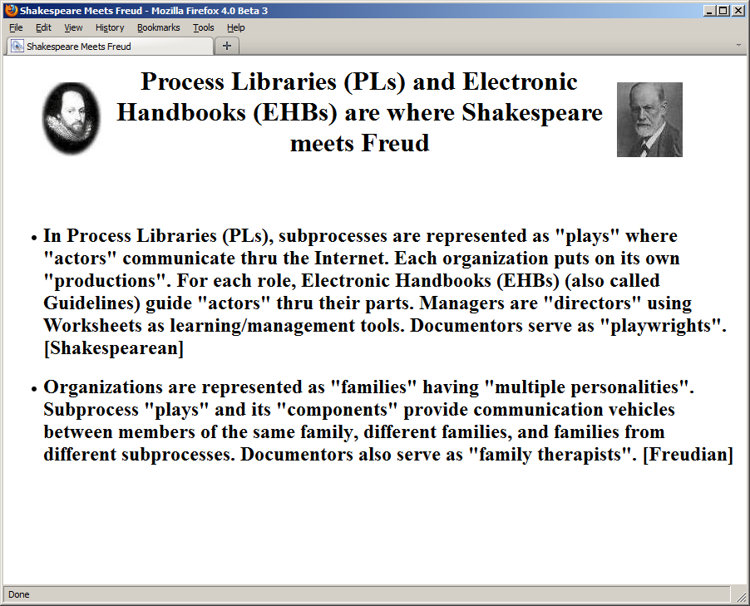

Figure 2(f). Process Libraries (PLs) and Electronic Handbooks (EHBs) are where Shakespeare meets Freud.
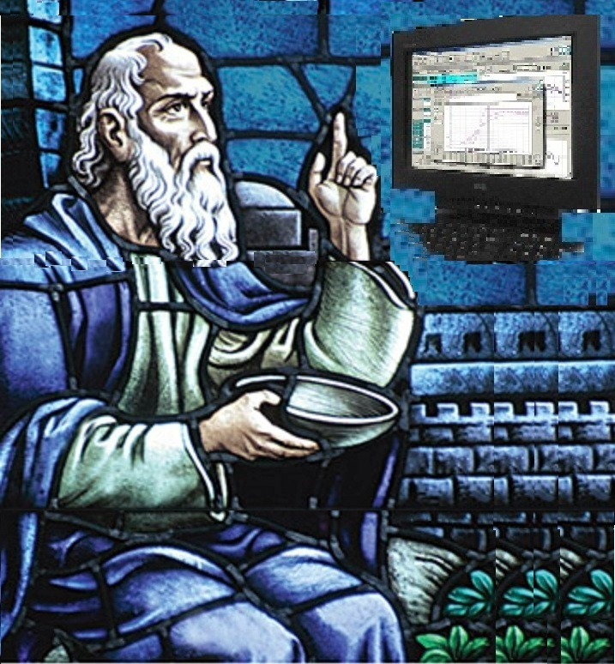
Figure 2(g). The approach uses a modernization of the Socratic Method or Dialogue to gain consensus between teachers, documentors, managers, implementors, and participants.
Figure 2(h). Some Process Libraries (PLs) and Electronic Handbooks (EHBs) projects.
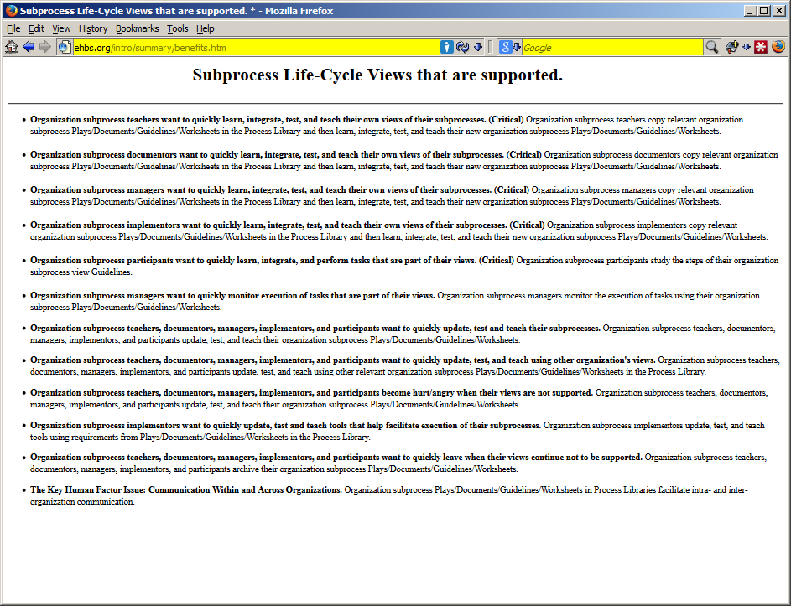
Figure 2(i). The Subprocess Life-Cycle Views are supported.

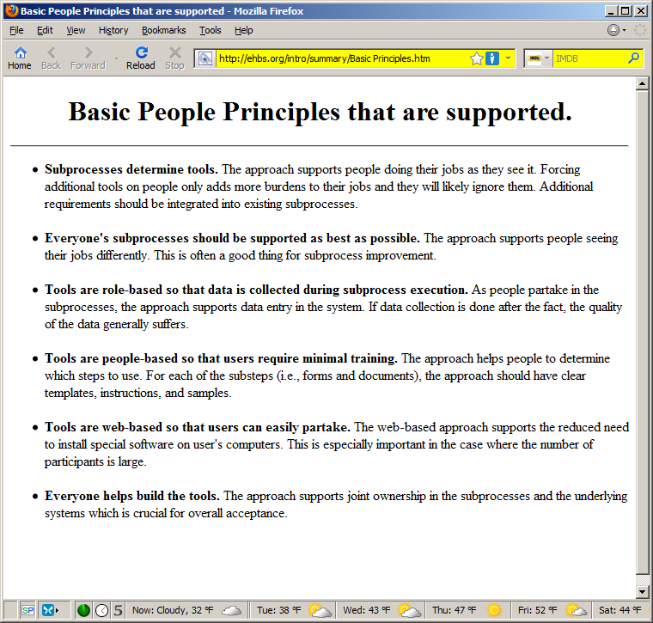
Figure 2(j). Basic People Principles that are supported.
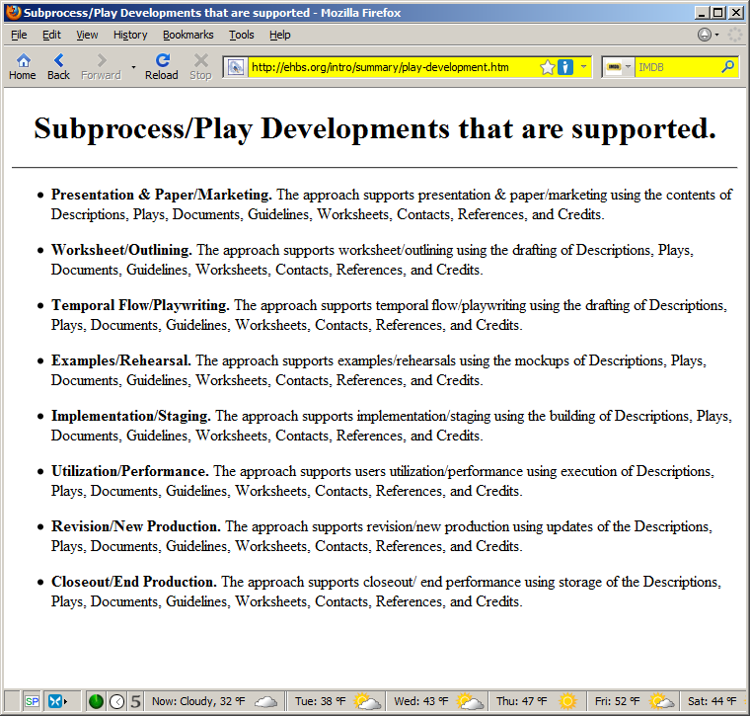
Figure 2(k). Subprocess/Play Developments that are supported.
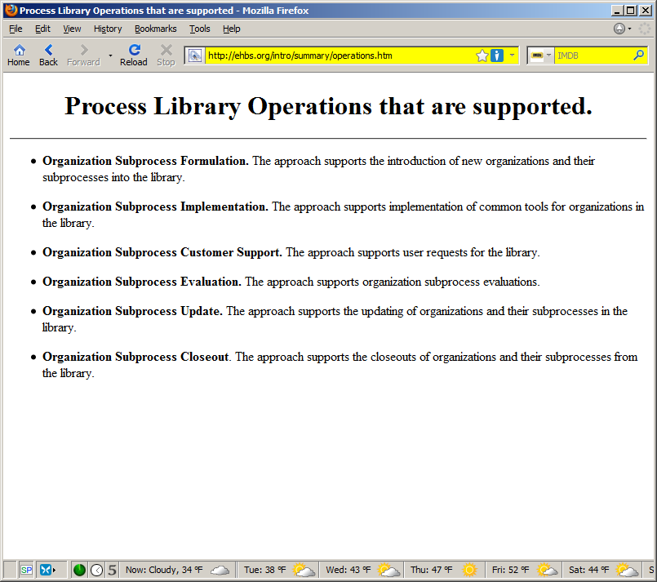
Figure 2(l). Process Libraries Operations that are supported.
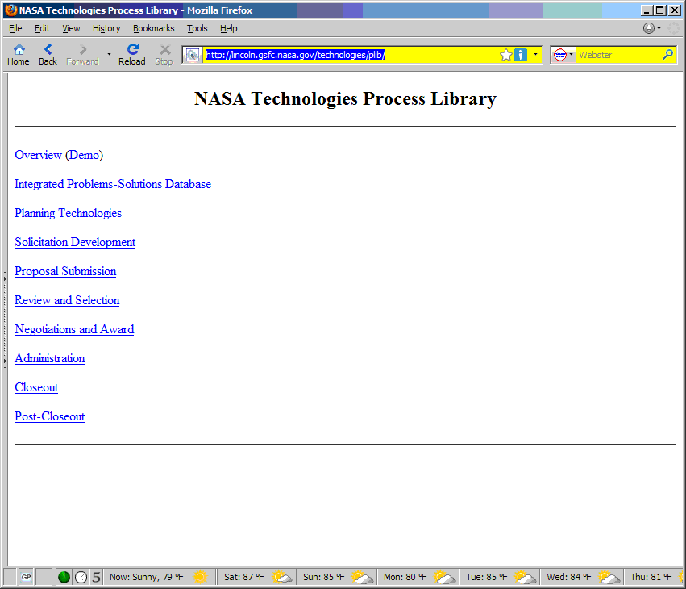
Figure 3(a). Process Libraries are organized by subprocesses.
Figure 3(b). For each subprocess, the library shows how organizations view the subprocess.
Figure 3(c). Components of an Organization's view .
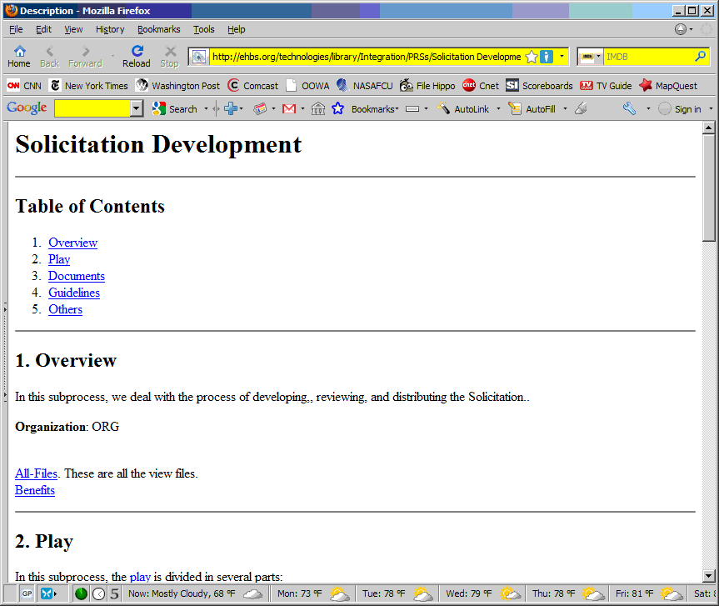
Figure 3(d). Descriptions summarize subprocesses.
Figure 3(e). Plays describe subprocess execution.
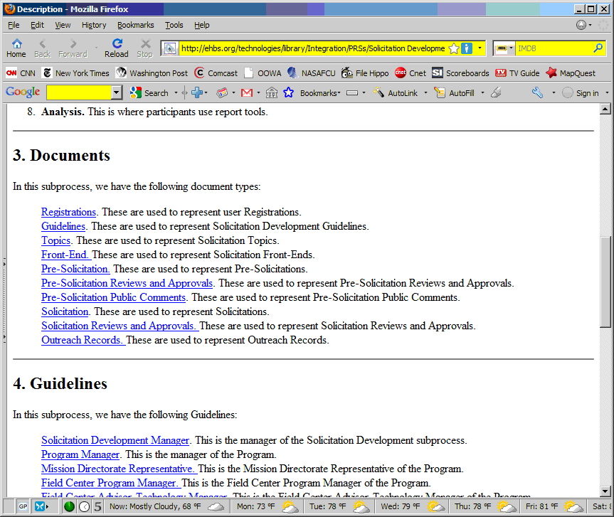
Figure 3(f). Documents describe subprocess data.
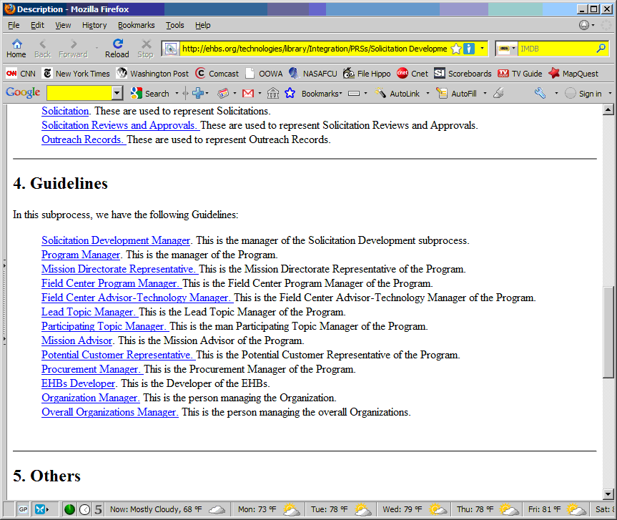
Figure 3(g). Guidelines/Electronic Handbooks describe user subprocesses.
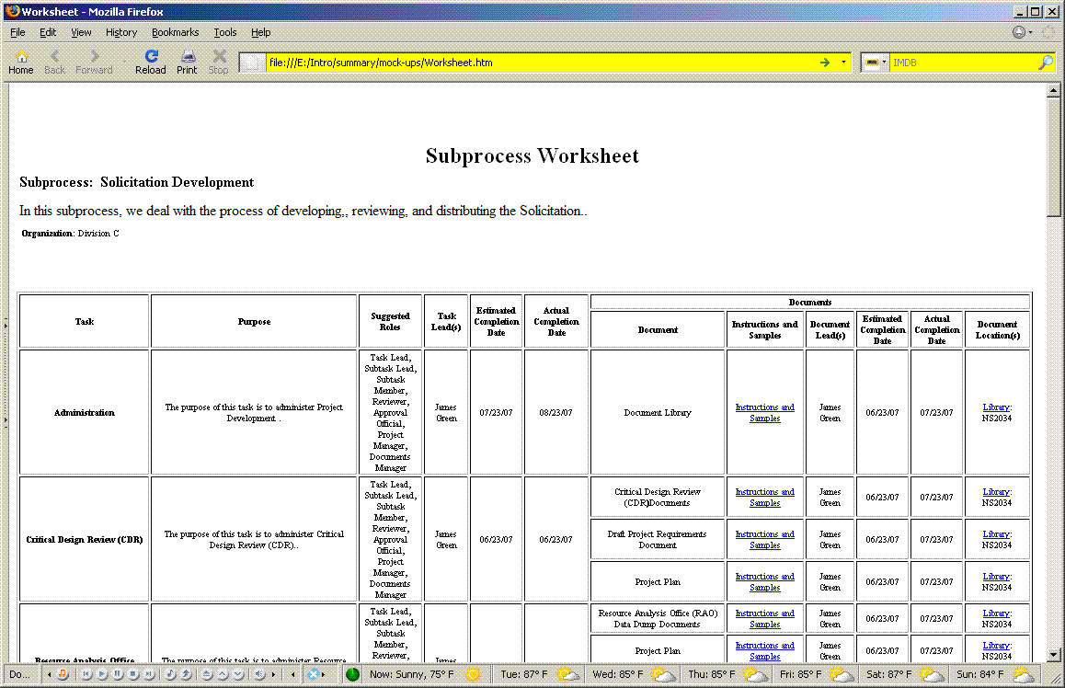
Figure 3(h). Subprocess Worksheets facilitate subprocess manager communication with process developers and participants.
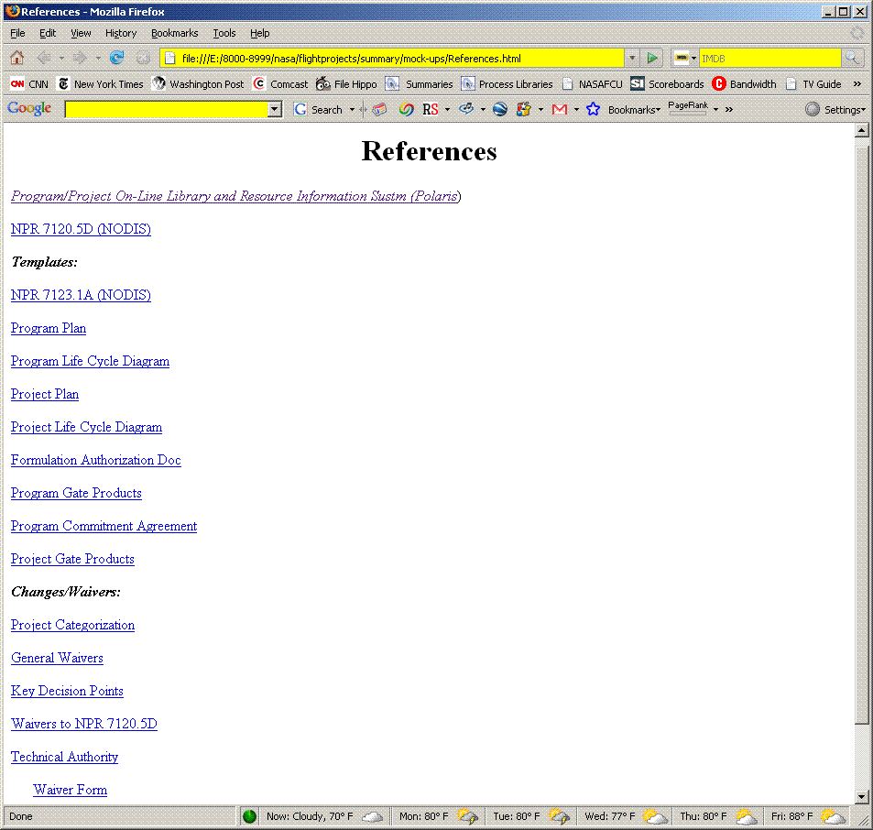
Figure 3(i). References list other related resources.
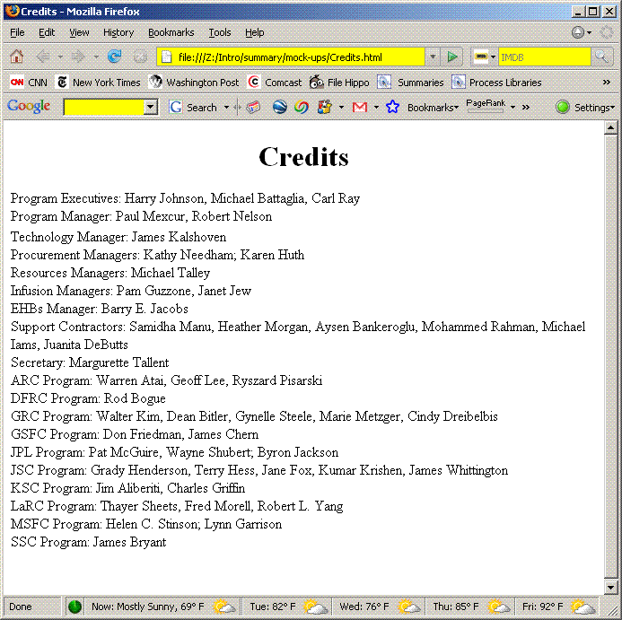
Figure 3(j). Credits acknowledge people's contributions.

Figure 3(k)(1). Some tools may be focused on during stages- by tool.
Figure 3(k)(2). Some tools may be focused on during stages- by stage.
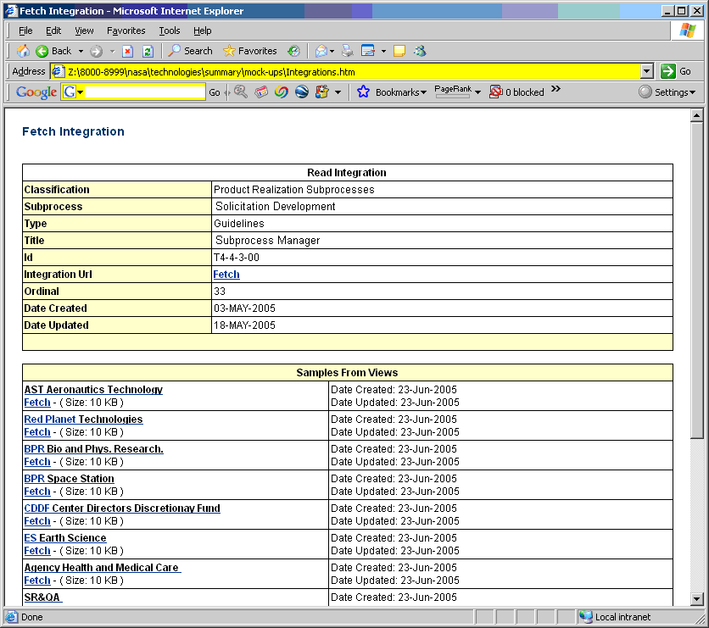
Figure 3(l). Integration Tools allow item types to be seen across different organizations.
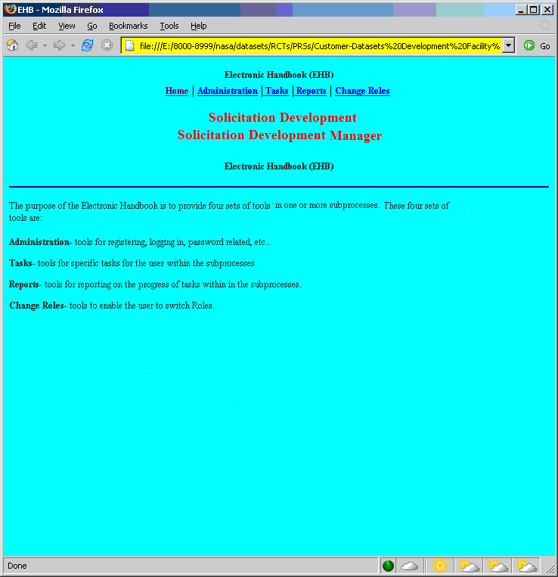
Figure 3(m). Electronic Handbooks (EHBs) help participants learn and execute their roles.
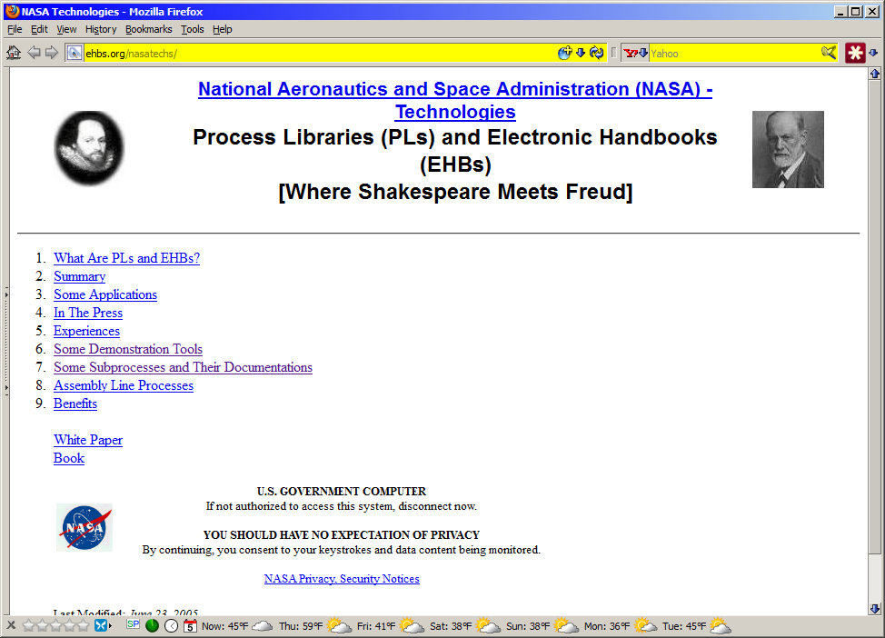
Figure 3(n). Demonstration Tools introduce the concepts to a community in their terms.
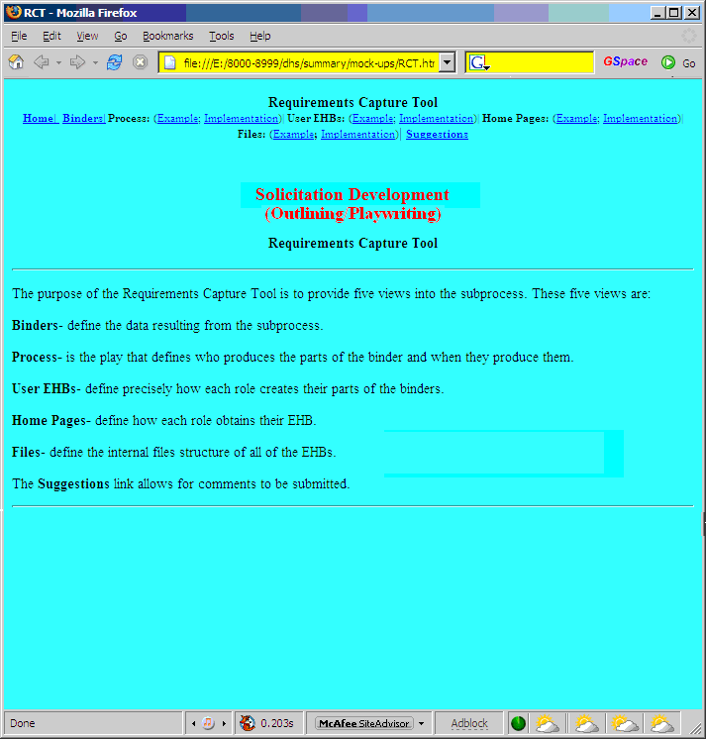
Figure 3(o). Requirements Capture Tools (RCTs) facilitate subprocess development.
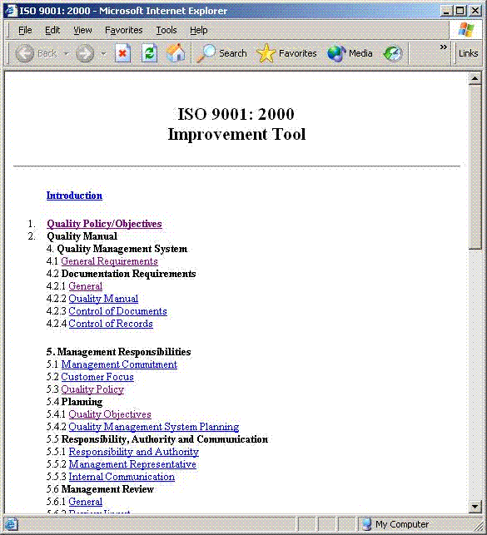
Figure 3(p). Improvement Tools facilitate subprocess improvement.

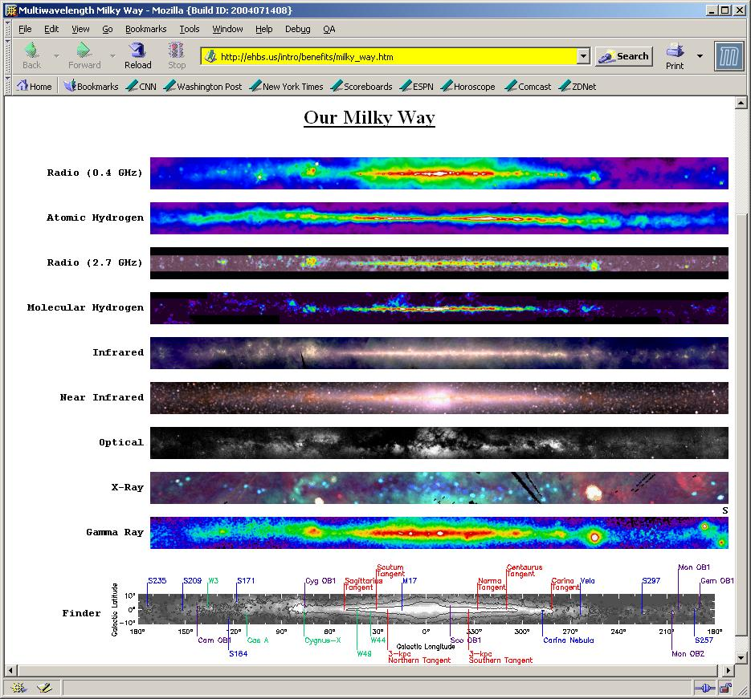
Figure 4(a). We believe that to truly understand one's universe, one must see it thru multiple "eyes" and also have tools to "communicate" these views.
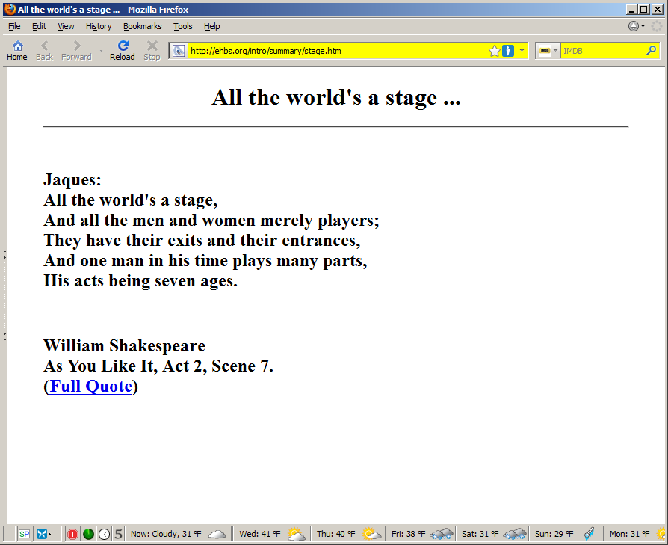
Figure 4(b). All the world's a stage ...
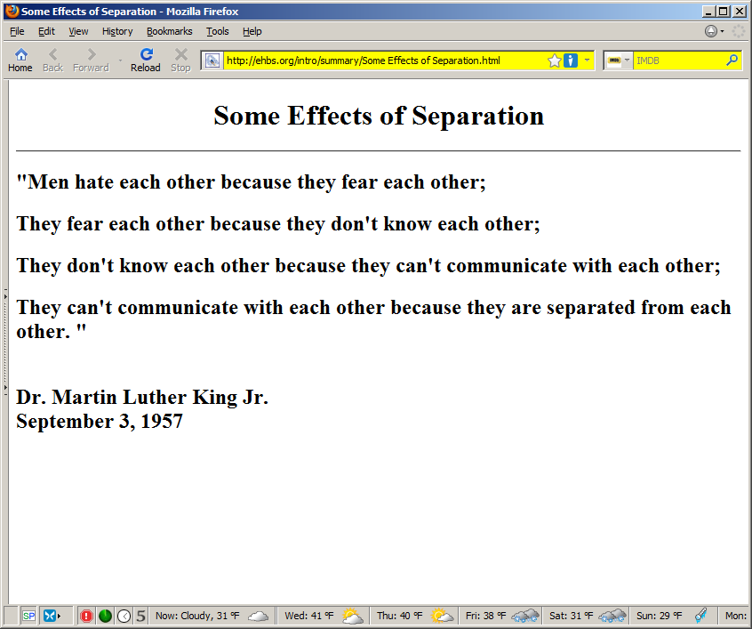
Figure 4(c). Some effects of separation.

